   | Newton Moore Senior High School  Year 12 Physics ATAR Unit 3 & 4  2019  Task 3: Experiment 4.1 Validation | Result:  / 44

Student’s name: |  | Total marks: | 44
Teacher’s name: | Kevin Lloyd | Weighting: | 5%
Assessment type: | Test | Time allocated:  Due date: | Term 1 week 6

Going around in circles – Experiment 4.1 Validation Test
(Use diagrams where appropriate)

- How is the centripetal force provided when using the apparatus in this experiment? (2 Mark)
______________________________________________________________________________________________________________________

- Explain why the tape in the apparatus must not touch the bottom of the tube. (2 Marks)
________________________________________________________________________________________________________________________________________________________________________________________________________________________________________________

- Write a valid hypothesis for this experiment (either part A or B). (3 Marks)
________________________________________________________________________________________________________________________________________________________________________________________________________________________________________________________________________________________________________________________________________________________________________
- What did the slope of the centripetal vs. velocity squared represent? Demonstrate using formula manipulation. (3 Marks)
________________________________________________________________________________________________________________________________________________________________________________________________________________________________________________________________________________________________________________________________________________________________________

- Does the fact that the string holding the stopper is not exactly horizontal affect the relation between Fc and v? Explain. (3 Marks)
________________________________________________________________________________________________________________________________________________________________________________________________________________________________________________________________________________________________________________________________________________________________________

- Determine the relation between F and v in terms of the angle between the string and the horizontal. (3 Marks)
____________________________________________________________________________________________________________________________________________________________________________________________________________________________________________________________________________________________________________________________________________________________________________________________________________________________________

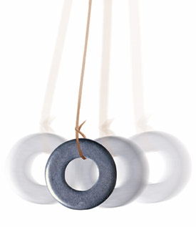

- The bob of a pendulum swings through a circular arc of constant radius. At what point of the swing does the cord holding the bob exert the greatest centripetal force on the bob? Explain. (3 Marks)
________________________________________________________________________________________________________________________________________________________________________________________________________________________________________________________________________________________________________________________________________________________________________
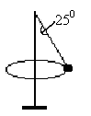
- In a game of totem tennis, a 0.120 kg ball is moving at a constant velocity in a horizontal circle around the pole as shown. The rope forms an angle of 25.0⁰ to the pole and the horizontal radius of the ball is 1.20 m. The ball takes 0.800 s for one revolution.

- Draw and label the forces acting on the ball. (2 Marks)

- What is holding the ball up? (3 Marks)
__________________________________________________________________________________________________________________________________________

- What is the ball’s acceleration? (2 Marks)

- What is the tension in the string? (3 Marks)

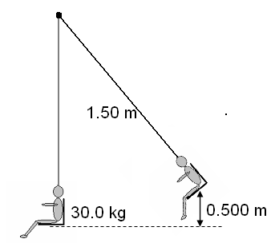
- A child is sitting on a swing and has been pulled back so that the seat is 0.500 m above the lowest point in the swing. The seat is then released.

- Calculate the velocity of the swing at its lowest point. (2 Marks)
- Calculate the tension in the ropes of the swing when a 30.0 kg child is moving through the lowest point in the swing, which has a length of 1.50 m. (3 Marks)

- A hammer thrower is swinging his 7.25 kg hammer at an angle of 40.0⁰ to the horizontal at a speed of 10.0 ms⁻¹. If the length of his arms are 0.500 m and the length of the wire is 0.700 m, calculate:

              - The centripetal acceleration. (2 Marks)

              - The centripetal force. (2 Marks)

              - The tension in the wire at the top of the swing just as the ball is on the way down.
(3 Marks)

              - The tension in the wire at the bottom of the swing just as the ball is on the way up. (3 Marks)

END OF VALIDATION

